
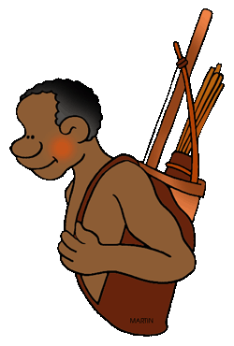

Indigenous tools and weapons:

NAME: __________________________________________________

Simple machines have been used in our Indigenous Australian culture for over 35000 years. It is your task to either design a simple machine of your own, or to find an existing Indigenous Australian tool and make alterations to better the tool itself (refer to Pearson 7, page 305 for an introduction to Indigenous tools).

WHAT TO DO:
- RESEARCH – Use the internet to find a tool or weapon used by Indigenous Australians. Some examples include a spear thrower or stone tools.
- Write the name of the weapon or tool below:

- What type of simple machine(s) are in the tool or weapon you chose?

- What was the tool or weapon used for in Indigenous culture?

- What was the tool/weapon made from?

- Draw a sketch of the tool/weapon in the box below. Label your sketch with the names of the simple machines it uses:

- MODIFICATIONS – Now you need to think of different ways that the tool/weapon you chose could be changed to make it more effective.
- List what sorts of things the tool/weapon should be able to do after you improve it (e.g. travel further, be better at cutting things, fly faster, need less force to work….):

- For each improvement you wrote above, how are you going to make this happen? (e.g. make the tool/weapon longer or shorter, add a new part, change its shape…):

- What materials could be used to make these changes to your tool/weapon? Remember that you should only use materials that Indigenous Australians would have used (e.g. native to Australia and easy to find):

- Draw a sketch of the new tool/weapon in the box below. Label your sketch with the names of the simple machines it uses AND the materials each part is made from:

BONUS POINTS: Make a model of your new tool/weapon
If you would like to make a small version of your new tool/weapon, you will need to bring in your own materials and only work on it if your teacher gives you permission to do so. Otherwise, you will need to spend time at home completing this.
Bring your finished model into class to show your teacher for a bonus prize!

PHOTO OF YOUR FINISHED MODEL:

History of tool/weapon | Mark
Simple machine(s) used in design of tool/weapon  Purpose of tool/weapon in Indigenous culture  Materials used to make tool/weapon | 1  1  1
Sketch of tool is clear and neat  Labels of simple machines are legible and neat | 1  1
Modifications
Reasons for modifications (at least 2) | 2
Descriptions of modifications (at least 2) | 2
Materials native to Australia (reference to at least 1 native flora) | 1
Sketch of tool/weapon is clear and neat | 1
Labels of simple machines are legible and neat  Labels of materials are legible and neat | 1  1
TOTAL
/ 13

